*NEVER PULL DO FETCH AND REBASE (It avoids merge commits which we don’t want to push)*

1. Click right button of mouse on ocean-lbg (check below screen shot) and select Fetch From Upstream

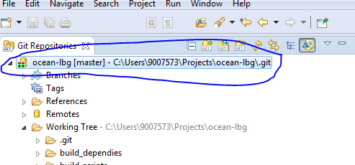

* It will fetch latest updates from remote repository like below screen shot.
* Click on ok
* If you want see the update details, you can click on commit id:commitmessage

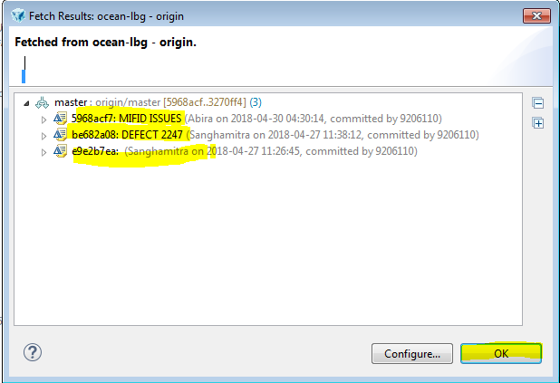

1. Click right button of mouse on ocean-lbg (check below screen shot) and select Rebase...



* Select origin/master and click on Rebase
* Click on Ok on popup window

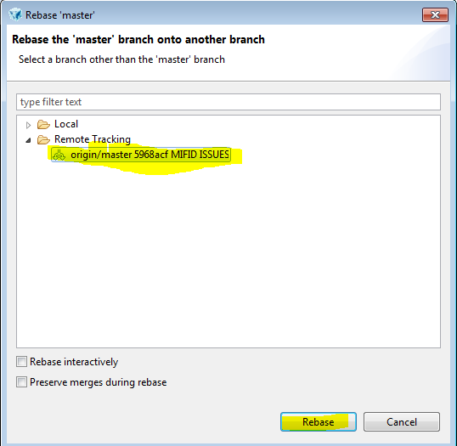

**2nd case:**

* If you see conflicts window like below screenshot. Follow below steps...
* Then check on Skip this commit and continue rebasing the next commits and click OK.

(It will update your workspace with remote changes)

* Then click OK on popup window.

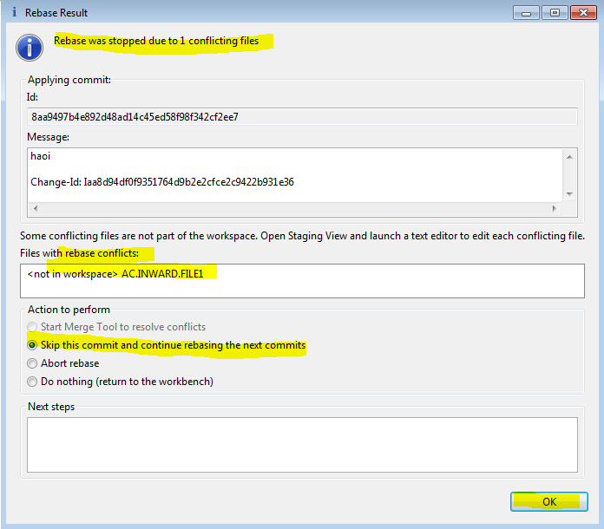

HOW TO RESOLVE GERRIT CONFLICTS DOCUMENTATION [CLICK- HERE](http://teamspace.intranet.group/sites/IslandsIT/IRP/General/Devops/Git/HOW%20TO%20RESOLVE%20GERRIT%20CONFLICTS.docx)